Experiment 20: Sharpening of Image using Laplacian Mask with Negative Center Coefficient
Software / Tools: Python · OpenCV (cv2) · NumPy

AIM
To sharpen an image by convolving it with a Laplacian mask whose center coefficient is negative, then subtracting the result from the original image.
ALGORITHM
1. Import OpenCV and NumPy.
2. Read the input image.
3. Define the Laplacian kernel [[0,1,0],[1,-4,1],[0,1,0]] (negative center).
4. Apply cv2.filter2D() with this kernel to get the Laplacian (edge) response.
5. Since the center is negative, sharpen using: sharpened = original - laplacian.
6. Clip pixel values to the valid range [0,255] and convert to uint8.
7. Display and save the sharpened image.
PROGRAM (SOURCE CODE)
import cv2
import numpy as np

img = cv2.imread("image.jpg")

kernel = np.array([[0, 1, 0],
[1, -4, 1],
[0, 1, 0]])

laplacian = cv2.filter2D(img, cv2.CV_64F, kernel)
sharpened = np.clip(img.astype(np.float64) - laplacian, 0, 255).astype(np.uint8)

cv2.imshow("Sharpened (Negative Center)", sharpened)
cv2.waitKey(0)
cv2.destroyAllWindows()

OUTPUT
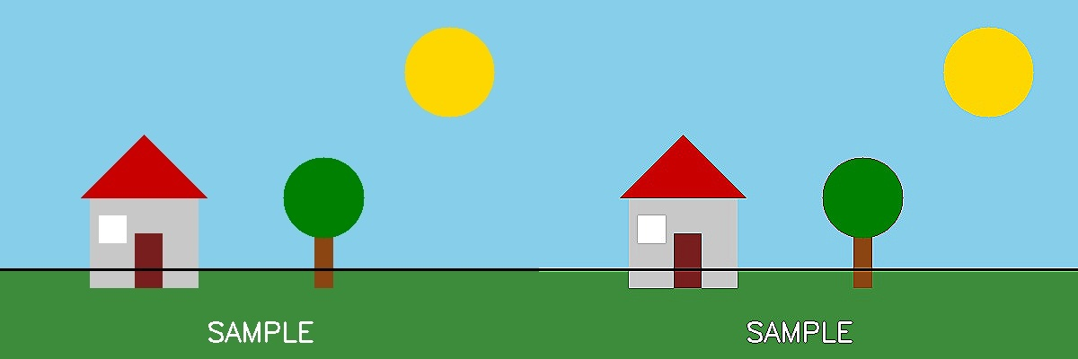
Fig. 20 — Output of Experiment 20: Sharpening of Image using Laplacian Mask with Negative Center Coefficient.
RESULT
Sharpen an image by convolving it with a Laplacian mask whose center coefficient is negative, then subtracting the result from the original image — completed successfully, as demonstrated in the output shown above.

